



Essay / Assignment Title: Big Data Analytics

Programme title: Big Data Analytics

Name: Faisal Khan Dahri

Year: 2025

CONTENTS

INTRODUCTION 4
Task 1: Big Data Analytics 5
Task 1.1: Real World Case Study 5
Task 1.2: Choosing Our Dataset 6
Task 2: Cloud Environment 8
Task 2.1: Setting Up Cloud Environment 8
Task 2.2: Cluster Configuration 8
Task 2.3: Uploading Data to HDFS 9
Task 3: Data processing using Hadoop & Spark 12
Task 3.1: Initiating Hadoop Job 12
Task 3.2: Initiating Spark Job 14
Task 4: Advance Analytics and Machine Learning 20
Task 4.1: Model Selection 20
Task 4.2: Model Evaluation 23
Task 4.3: Visualizing Result 24
CONCLUDING REMARKS 27
BIBLIOGRAPHY 28

Statement of compliance with academic ethics and the avoidance of plagiarism

I honestly declare that this dissertation is entirely my own work and none of its part has been copied from printed or electronic sources, translated from foreign sources and reproduced from essays of other researchers or students. Wherever I have been based on ideas or other people texts I clearly declare it through the good use of references following academic ethics.
(In the case that is proved that part of the essay does not constitute an original work, but a copy of an already published essay or from another source, the student will be expelled permanently from the postgraduate program).

Name and Surname (Capital letters):

.............................................FAISAL KHAN DAHRI..........................................................................................

Date: ..............13.........../.... February.... /.....2025....

INTRODUCTION

In this assignment below we will create an end-to-end Big Data analytics project demonstrating key learning objects regards the basic concept of big data, its benefits, uses, key technologies and architecture.
This assignment will be divided into 4 major tasks where primarily, we shall start by identifying a case study where big data analytics can be used to drive valuable insights, we will prove a short report on the need of big data in business context. And then after we shall download a dataset >10 GB for our Big data analytics within this project.
Under task 2 we will use ‘Google Cloud’ as our cloud platform using ‘Dataproc” for our processing environment, explaining each step, then we shall document configuring a cluster and we will upload our dataset to Hadoop distributed file system, explaining what HDFS is and its benefits.
Under task 3 we will initiate a Hadoop map reduce word count job and a spark data aggregation, filtering and exploratory data analysis job using python code.
And finally, under task 4 we will deploy a ‘Random Forest’ machine learning model using Apache spark Malli to make certain predictions, we will give reasons for our model selection and use different evaluation metrics to evaluate our prediction, each steps taken and the prediction will be explained in detail below.
And in the end, we will write our conclusion.

Task 1: Big Data Analytics
Under task 1 we shall primarily identify real-world case study where big data analytics can be used to drive decision making, we will explain what is big data, why is it needed and how data analytics at a larger scale can provide value in solving problems. And lastly, we will suggest and justify a dataset that we will be using in this project.
The technologies of collection, storing and processing of data has changed over time from using books for data entry to excel sheets then to relational database management systems i-e SQL databases to NoSQL databases and now on to big data technologies.

Task 1.1: Real World Case Study
Real-world case study where big data analytics can be used to drive decision making insights can be use of big data technology in retail. It can be used in ‘Descriptive analytics’ for describing sales performance analysis, for store traffic analysis, for inventory management, customer segmentation, tracking product performance, etc. It can be used in ‘Diagnostic analytics’ to identify sales decline, investigating profitability issues, operational challenges, customer behavior, etc. It can be used in ‘Predictive analytics’ to predict demand and sales forecast, personalized product recommendation, inventory optimization, etc. and it can also be used in ‘Prescriptive analytics’ to optimize store layout, workforce schedule, supply chain, dynamic pricing model, etc.
The volume and variety of data is rapidly increasing consisting of email, blogs, posts, images, videos etc. This is big data, fortunately this data can be analyzed and processed using clusters and thousands of computers to discover hidden patterns and insights in an inexpensive way (Rajaraman, 2016).
At this point in time big data technologies sit at the frontier of data technologies due to its cost effectiveness, variety of applications, ease of use and functionality. It comprising the benefits of both SQL and NoSQL technologies. Big Data technologies were developed to handle vast amount of data storing and processing unlike SQL databases it can store, structured, unstructured or semi-structured data, benefits with horizontal growth meaning storage can be increase indefinitely, it is cost effective because you only need to pay for the services you are using and saves you the hustle of maintaining an inhouse servers.
It gives you the access to the most modern data processing technologies such as Hadoop, spark and Kafka, it can be used in real time analytics and also for batch processing. It solves the 3V’s problem and provides us velocity, volume and variety.
Also, the fact that you are not only limited to using SQL language but you can use variety of languages to access these technologies such as python, java, SQL included, etc.
Furthermore, big data analytics at a larger scale can provide tremendous value in problem solving, having a large, consistent and clean data set can be used to drive valuable insights using big data in a variety of industries for example, in banking and finance it can be used in fraud detection and risk management, in Health care it can be used in disease detection and patient care, in manufacturing it can be used for predictive maintenance and demand forecast, etc.

Task 1.2: Choosing Our Dataset
Moreover, in this assignment we shall be using a ‘Taxi Trips’ data set from Kaggle called “Taxi Demand Fare Prediction Dataset” by “Sohaib Anwaar” which is 11.43 GB. It will consist columns such as Vendor ID, pick up, drop off location, time of day, fare, etc. (Link to Kaggle dataset).
Figure1: Our Dataset
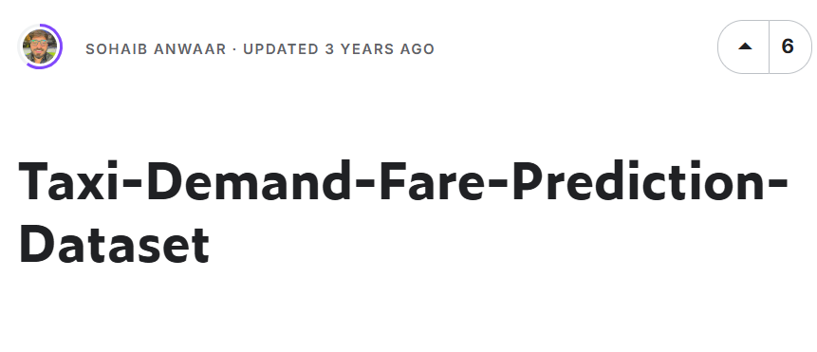

Figure 2: GB Storage and files
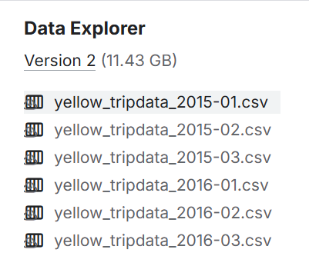
This dataset is >10 GB as per the requirement of the assignment.

Task 2: Cloud Environment

Task 2.1: Setting Up Cloud Environment
In this task we will setup our big data processing environment using the cloud platform ‘Google cloud’ with ‘Dataproc’ as our big data processing environment, then we shall configure our cluster considering cost, scaling options and selecting appropriate instance type and in the end, we will upload our dataset into HDFS and explain ingestion process and ensuring data is properly stored across all nodes.
Today all the companies try to use their large amount of data to gain insights and improve their business, and all the cloud providing services like Google and Amazon meet the market demand (Lombardo, 2019).
As per the first step we have selected Google cloud as our cloud platform using Dataproc as our big data processing environment because it has a fast setup, we can access Hadoop and spark engines, it has auto scaled and good for cost control as we will be charged per second as per the services we are using.

Task 2.2: Cluster Configuration
Furthermore, we will create our cluster and configure it, a cluster is a group of virtual machines which is used to process data. To configure our cluster will we choose a region where the data will be stored and processed, we choose ‘Europe west 3’, then we choose the cluster type to ‘Standard’ meaning 1 master node accompanies by multiple worker nodes, better for large scale data processing, the machine type we will choose ‘N1’ this is suited for cost efficiency. Successfully creating our cluster.
Figure 3: Cluster Created
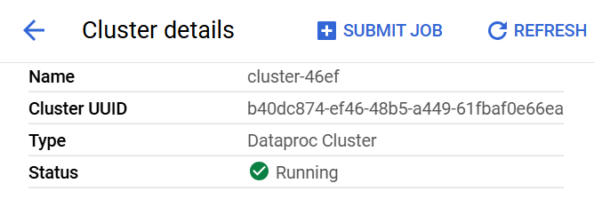

Task 2.3: Uploading Data to HDFS
Furthermore, this we will first upload our file available in csv format on to our Google cloud data bucket from there transfer it to HDFS.
Figure 4: Uploaded file to data bucket
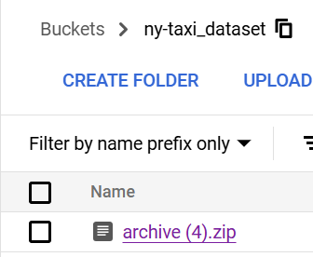
Then after, we will write code using SSH terminal on our cluster to upload this file into the HDFS system, but first we need to unzip the file, for this we wrote simple unzip command and save the files back into our bucket.
Figure 5: Unzip Files
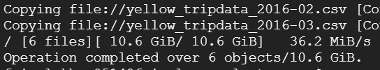
Which gave us 10.6 GB of data and hence, as per the requirement of this assignment we will be using a dataset >10GB.

Figure 6: Stored files unzipped
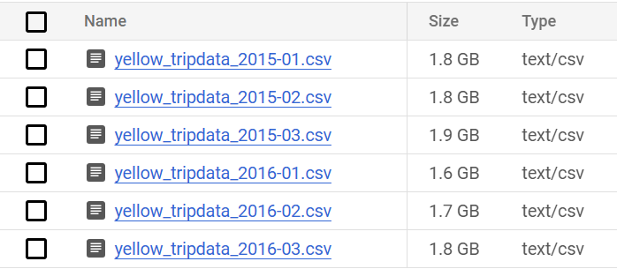
TRANSFERING THE FILES TO HDFS
Moreover, we will upload our file on to HDFS which stands for ‘Hadoop Distributed File System’, it is used to store large file by breaking them down into multiple blocks where each block has a copy ensuring data safety and availability even in case of system crash.
Figure 3: Transferring file to HDFS
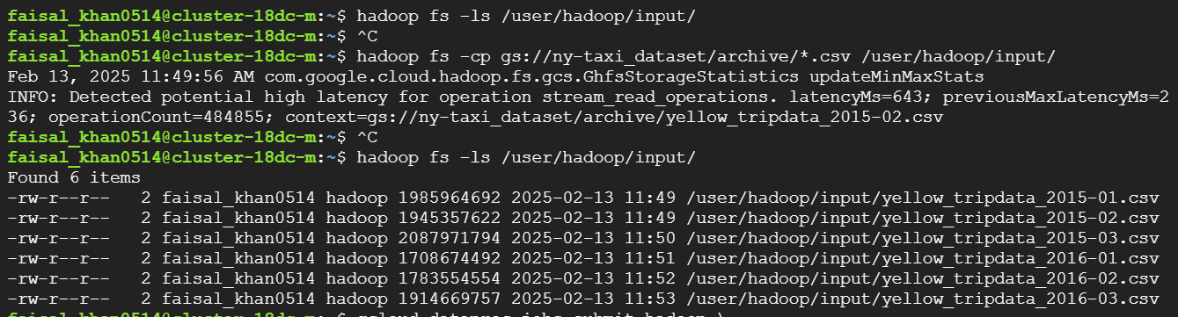
Here we used the command ‘Hadoop fs -cp’ to transfer the file from GCS (Google cloud bucket) to HDFS, we designated the file path and storage location, then we ensured the safe transfer of the file.

Figure 7: HDFS file Memory
We will compare the memory space, to ensure the entire file has been successfully transferred, which gave us the numbers of ’10.6 GB’ as total memory and HDFS file but, it can be seen in the HDFS this file storage has been increased, this is because the HDFS system automatically creates duplicated to ensure fault tolerance and data availability. Hence, with this our second task has been concluded.
Hadoop has become highly popular solution to store data using its ‘Hadoop Distribution file System’ (HDFS) and Yarn architecture (Weets, Kakhani and Kumar, 2015).

Task 3: Data processing using Hadoop & Spark
Uder this task primarily we will use Hadoop Map reduce to conduct a word count frequency. Then after, we will use Apache Spark to perform advance data transformation and processing by data aggregation, filtering and exploratory data analysis.

Task 3.1: Initiating Hadoop Job
For the Hadoop job we will write a python code to perform a map reduce to conduct a word count frequence calculation of our column “Vendor ID”, to show the vendor id was reaped how many times across the dataset.
For this primarily, we will write our map reduce code upload it to the HDFS and there after use our HDFS input file, mapper and reducer file to conduct the calculation, it should be stated that to conduct a Hadoop job the files should be located on the HDFS and we would also need a Hadoop streaming path so that the python code can by run on the system because usually Hadoop is costumed to java and not python, the Hadoop streaming path in our case is “/usr/lib/hadoop/hadoop-streaming-3.3.6.jar”.
Figure 8: Uploading files to HDFS
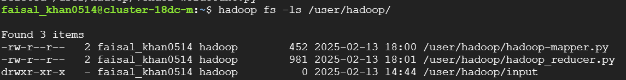
After successfully uploading the files, we will create our job.

Figure 9: Inserting the Hadoop streaming path
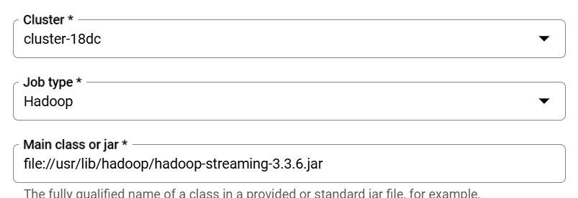
On the space for jar we inserted our streaming path so that Hadoop can read our python file.
Figure 10: Arguments Input
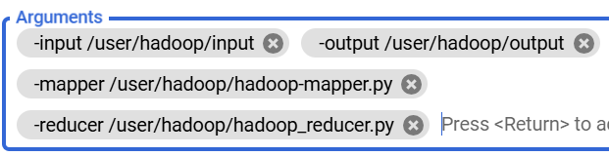
As for the ‘Argument’ space we wrote our input, output paths, path to our mapper and reducer python file present on HDFS.
Figure 11: Result of Word Count
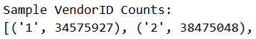
This shows that Vendor ID 1 was repeated ‘3457927’ times and vendor id ‘2’ was repeated ‘38475048’ times.
Vendors who have implemented Hadoop is because of it’s effectiveness and ease of using map reduce in parallel with many data analysis algorithms (Taylo, 2010).

Task 3.2: Initiating Spark Job
Furthermore, we will conduct an Apache Spark job where we will updated our data time format, performed EDA calculating the statistical summary of our key values, aggregate the average fare amount, total fare amount by each month and created a new column calculating the total trip duration.
For this data processing we will use ‘pySpark’ will first need to write our python file with the necessary calculations and an input path and an output location (Python script link). We will then save this file to our GSC, create a job on to our cluster using ‘pySpark’.
Below we will try to explain the step we took and explain each step one by one and share the concluded results (Python File link).
Figure 12: Successful job processing
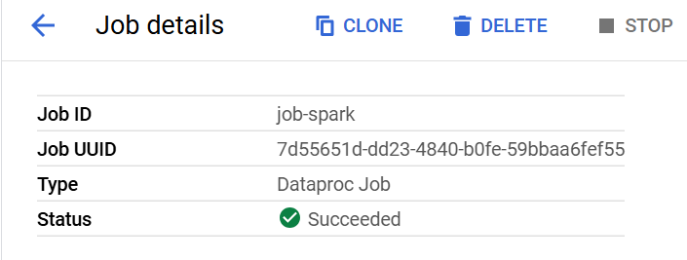
Our python script run successfully within the pyspark framework under this job.
Figure 13: Python Code for Date time format conversion
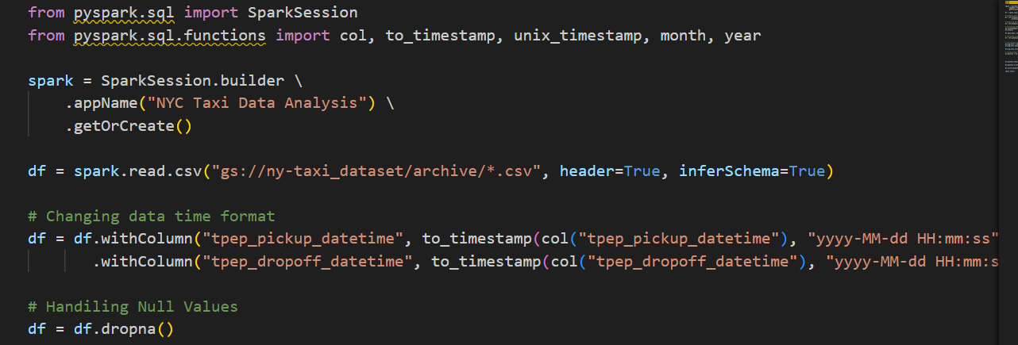
Figure 14: Result of Date time conversion
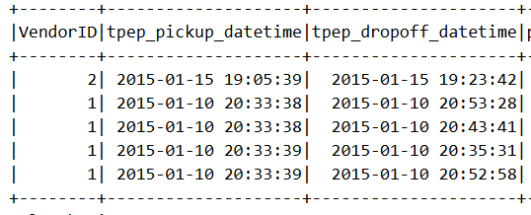
Primarily, we converted our data time column into timestamp format i-e "yyyy-mm-dd hh:mm:ss", we handled all the missing values by dropping the rows with null values using “df = df.dropna()”.
Then we did ‘Exploratory data analysis’ (EDA) by printing the dataset top 5 rows to review our columns and the available data within them, so we may have a layout of the data we are dealing with, after which we will calculate the summary statistics of the numeric column within our data set.
Figure 15: Code for EDA
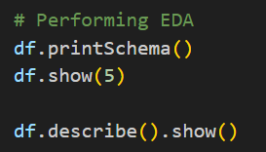

Figure 16: Exploratory Data Analysis (EDA)
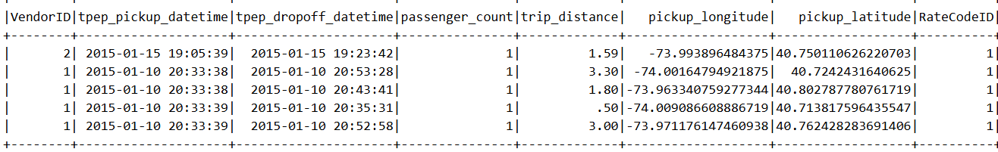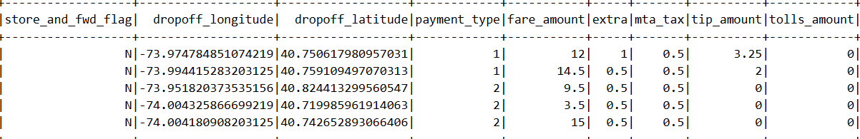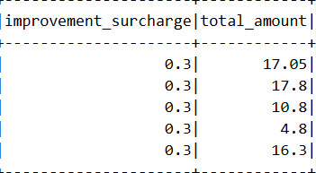
Figure 17: Calculation the summary of the numeric values
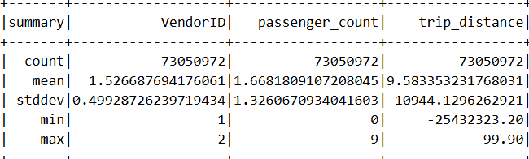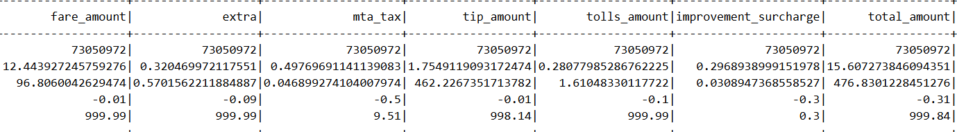
This summary statistics gave us the total count, mean, min, max of the values within our data set providing further insight and understanding of our data.
Moreover, we will try to aggregate the average fair amount.

Figure 18: Code for Aggregating Average fare
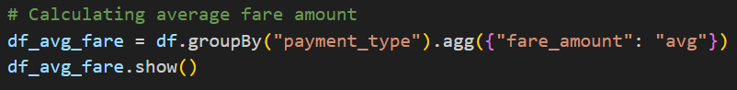
Figure 19: Result Average Fair amount
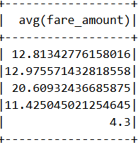
Furthermore, we calculate the sum of total fare per month and payment type.
Figure 20: Code for Sum of Total fare per month
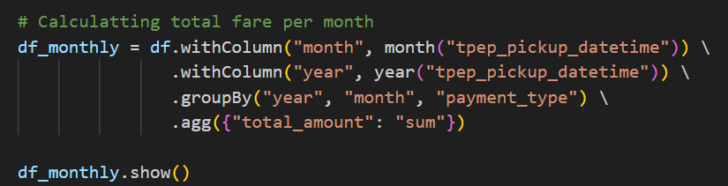

Figure 21: Result Sum of Total fare per month
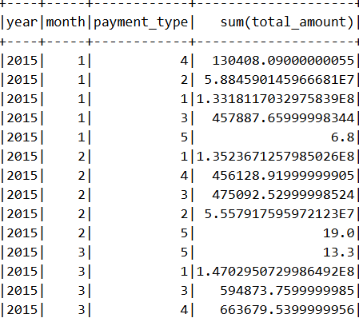

And finally, we calculated the trip duration using the pick-up and drop-off time.
Figure 22: Code for calculating trip duration

Figure 23: Result Calculating Trip duration
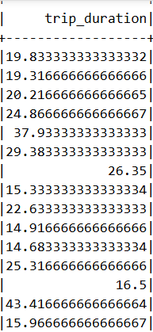
Hence, using spark we have updated our data time format, performed EDA calculating the statistical summary of our key values, summed up the average fare amount, total fare amount by each month and created a new column calculating the total trip duration.
(Link to the Python Code).
Apache spark has emerged as the best frame work for big data analytics, with advance in memory programing model, streaming technology, scalable machine learning, structured data processing, etc. with its variety of applicable languages such as R, Python, Java it is a rapidly evolving open-source project (Salloum et al., 2016).

Task 4: Advance Analytics and Machine Learning
Within task 4 we will use ‘Apache spark MLlib’ to implement ‘Random Forest’ machine learning model on to our data set to predict fare amount for the taxi trips based on our available columns such as pick-up point, drop-off location, no of passengers, duration of taxi ride, time of booking, etc. We will evaluate our model using the different evaluation metrics and visualize our findings.

Task 4.1: Model Selection
Our problem is a regression problem where we need to predict a continuous value using our input features, to solve this we choose to use ‘Random Forest’ machine learning model because of its ability to perform regression as well as classification problems.
Random forest works like a decision tree but has multitude of these decision tress each doing their independent predictions based on random subset of data and then the final model combines and averages the results of the independent trees. This model works well with high volume of data.
Random Forest machine learning model initially proposed in the 2000’s to build a predictor ensemble with a set of decision trees, these trees grow randomly in different subspaces of data (Biau, 2012).
Furthermore, we will write our Random forest ML python code to initiate the job using spark within our cluster (Link to the python code).
Figure 24: Random Forest ML Model Job Success
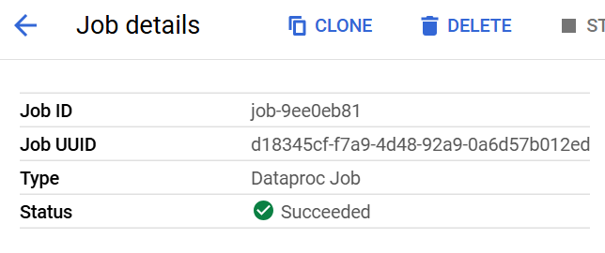
Moreover, we will explain our python code sharing screen shots of the code and in the end share the results.
Figure 25: Python Code Importing libraries and Data
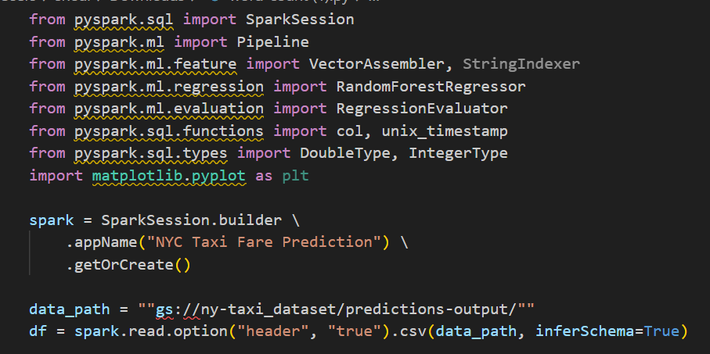
We imported the necessary libraries, initiated our spark session and gave the input path to our file location.
Figure 26: Python Code Data Transformation and cleaning
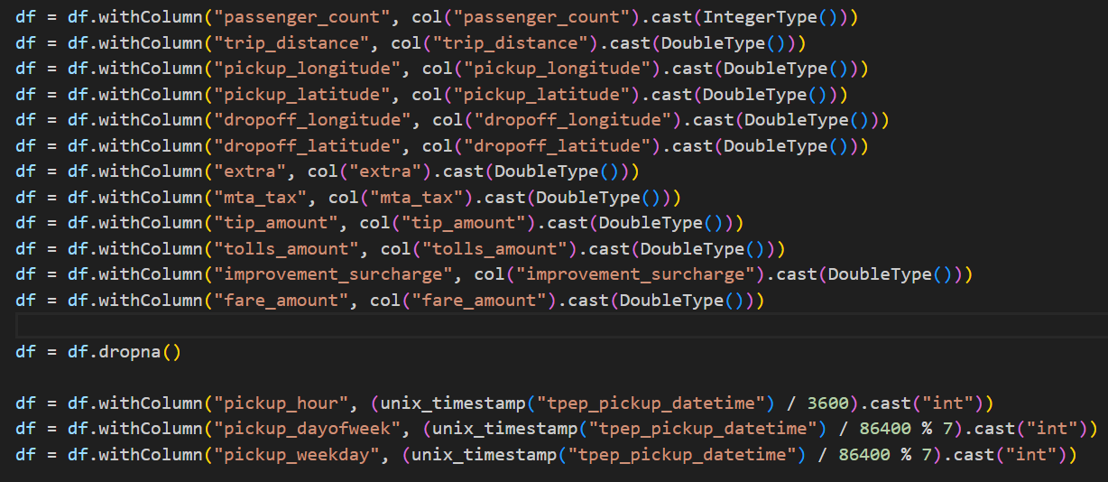
We transformed the data type, removed any null values and change our date time format.

Figure 27: Python Code for Random Forest ML Model Initiation
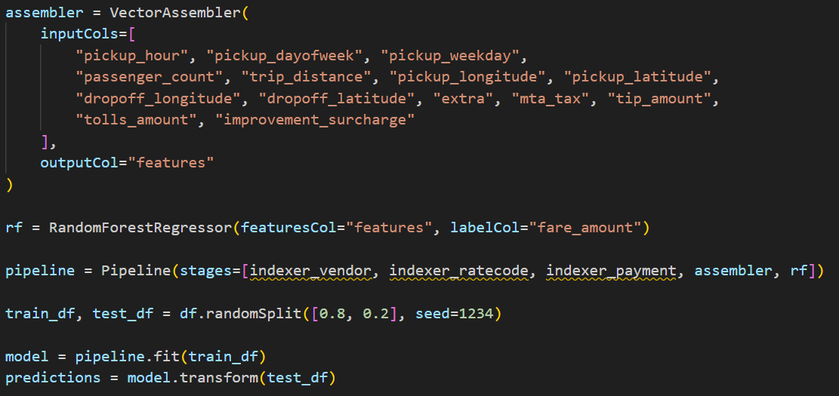
Then we initiate our ‘Random Forest’ model, trained and tested the model using the 80/20 rule meaning using 80% of data for training and 20% for testing it on itself so it will be market ready.
Figure 28: Python Code for Model Evaluation
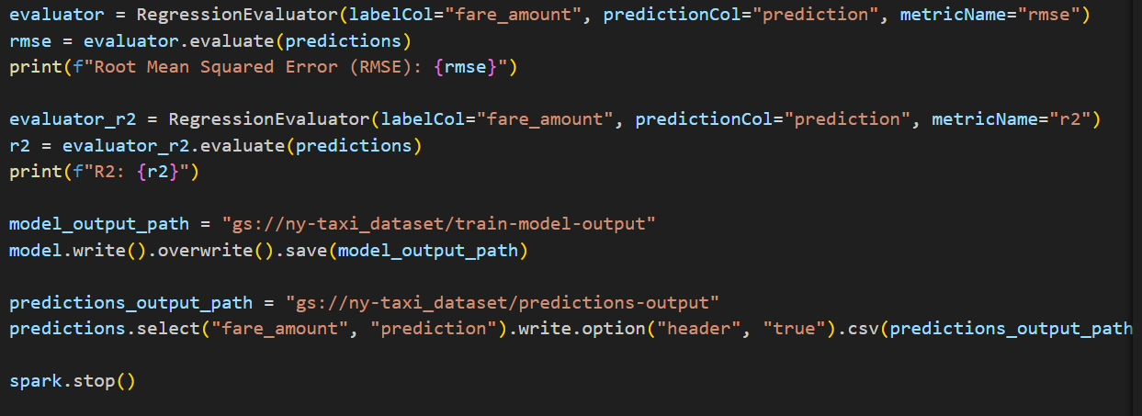

Task 4.2: Model Evaluation
Furthermore, we evaluated our model using the metrics Root Mean Square Error (RMSE) and R2 error. RMSE tells us how much predicted values are similar to the actual values whereas, R2 error tells us how well the target variable is explained by the model. And then after we save our output.
Figure 29: Result of Evaluation metrices
Lower RMSE is considered good, hence 4.3 is a good numbere but could have been better whereas, R2 closer to 1 is considered good hence, 0.8 will be considered a very good metric meaning as per our evaluation metrices our model is performing good.
Figure 30: Saved Files
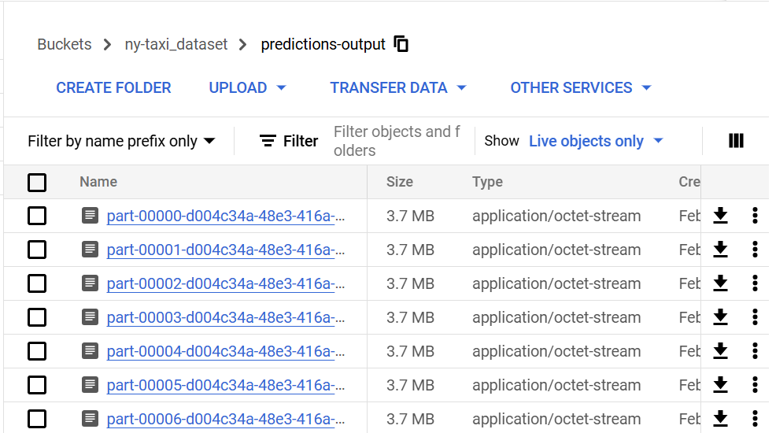
Our files for the predicted out come have been save into our bucket which we will further use to create our visualization for better understanding of the model.

Figure 31: Output Result in Excel
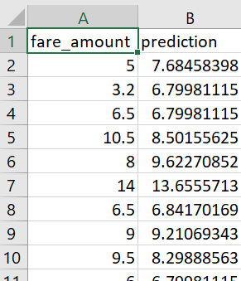

(Link to Random Forest ML model Python Code).
Prediction systems built around big data processing engine such as Apache spark with focus of applying machine learning model on streaming big data in a scalable system will help the applicants receive real time extracts (Nair, Shetty and Shetty, 2018).

Task 4.3: Visualizing Result
To visualize our predictions, we will be using a scatter plot visualization to visualize the relationship between our actual and predicted values. With this we will be able to understand the compare both the values, look out for any patterns and identify any outliers.
To conduct this visualization, we could have simply used the SHH terminal but we would like to explore other features of our ‘Google Gloud’ platform hence, we opted to use ‘Google Clouds Collab Enterprise’ present under the ‘Verte’s AI Notebook’ secession.

Figure 32: Importing necessary libraries
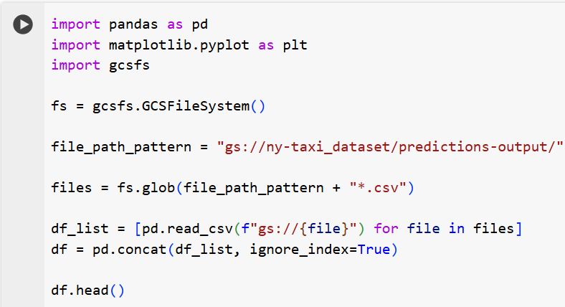
Primarily, we imported the necessary libraries, ‘pandas’ and ‘matplotlib’ for visualization and ‘gcsfs’ for reading our dataset from our bucket, the we printed the head of our dataset.
Figure 33: Dataset df.head()
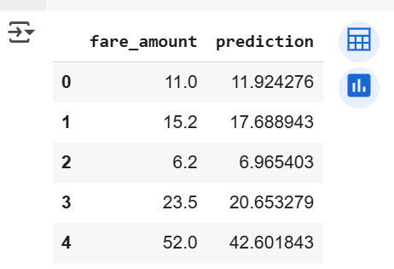
Figure 34: Scatter plot code
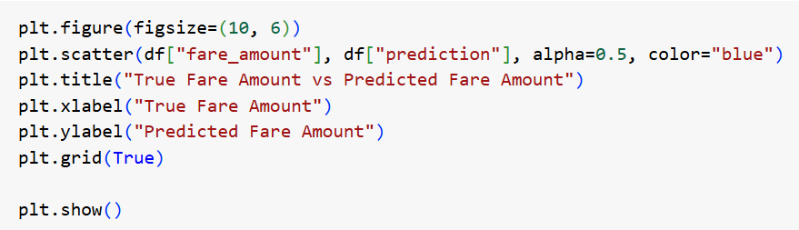
We gave the metrics for our visualization.
Figure 35: Result Scatter Plot Visualization
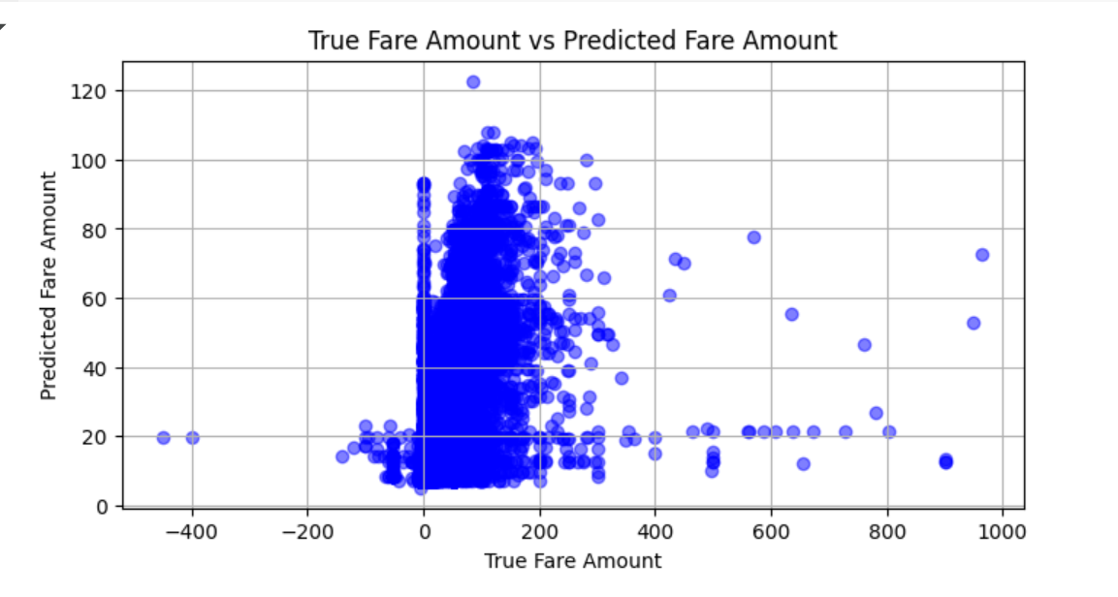
This is our scatter plot visulization where we can see the ‘True Fare Amount’ on the x-axis and the ‘Predicted Fare Amount’ on the y-axis, showing that our predicted and actual values does not have a mojor difference except a few outliers which can be due to expectional reasons and can be ignored.
In the conclusion we would like to high light the benefits of this prediction model, this model can be used to give the customer a fair rate for their trip in advance using their pickup and drop-off location, no of passengers, time of day, etc.

CONCLUDING REMARKS

In this assignment we defined the different intricacies of big data, we used Google cloud as our cloud platform for data storing and data processing whether it be using Hadoop for map reduce, Spark for data aggregation and performing EDA or creating a machine learning predictive model.
We went through all the steps from setting up our cloud platform, configuring clusters, storing data into data buckets and HDFS, interacting with the systems using SSH terminal or the dataproc interface, etc. We saw how easy it was to do all these task, how fast we can set up a cluster import our data and process it, not worry about scalability, CPU, RAM, or maintain a inhouse server, we found out that these services were not expensive as we only need to pay for the services we are using and if we decide to scale the system can take up the burden exponentially.
We saw a variety of jobs that can be conducted and the ease to deploying those jobs with the option of using variety of programing languages although we used python in our project but languages such as java, R, SQL, etc. may also be used.
This technology is truly revolutionary we have access to Hadoop for map reduce, batch processing, etc. we have Spark for real time processing, Yarn for resource allocation and much more making the job of a data analyst very easy and a goldmine for business to grow their businesses to new heights by maintaining, processing and scaling their data architecture to gain deep valuable insights.

BIBLIOGRAPHY

Rajaraman, V., 2016. Big data analytics. Resonance, 21, pp.695-716.
Lombardo, L., 2019. Autoscaling mechanisms for Google Cloud Dataproc (Doctoral dissertation, Politecnico di Torino).
Weets, J.F., Kakhani, M.K. and Kumar, A., 2015, October. Limitations and challenges of HDFS and MapReduce. In 2015 International Conference on Green Computing and Internet of Things (ICGCIoT) (pp. 545-549). IEEE.
Taylor, R.C., 2010. An overview of the Hadoop/MapReduce/HBase framework and its current applications in bioinformatics. BMC bioinformatics, 11, pp.1-6.
Salloum, S., Dautov, R., Chen, X., Peng, P.X. and Huang, J.Z., 2016. Big data analytics on Apache Spark. International Journal of Data Science and Analytics, 1, pp.145-164.
Biau, G., 2012. Analysis of a random forests model. The Journal of Machine Learning Research, 13(1), pp.1063-1095.
Nair, L.R., Shetty, S.D. and Shetty, S.D., 2018. Applying spark based machine learning model on streaming big data for health status prediction. Computers & Electrical Engineering, 65, pp.393-399.
Kaggle Dataset:
https://www.kaggle.com/datasets/sohaibanwaar1203/taxidemandfarepredictiondataset
Spark Job Python Code: https://github.com/FaisalDahri/Python-Code-files.git
Random Forest ML Model Python Code: https://github.com/FaisalDahri/Python-Code-files.git

